
Premises Management Statement
UNDER REVIEW
Approved by | Trust Board | Date Approved | 18 July 2023
Review cycle | 3 Years | Date of next review | Summer 2026

Version | Author | Date | Changes
1.0 | Jo Hawkins, COO | June 2023 | Reference to Conditions surveys and updated information on governance monitoring

Enlighten Learning Trust acknowledges accountability for adherence to the legislation and compliance requirements outlined in the Federation of Property Societies’ Compliance Monitoring for Council Buildings Report.

The individual schools’ local governing bodies must be aware of and adhere to the DfE guidance contained in Managing Asbestos in your School and Standards for School Premises, which help schools and local authorities understand and deliver their obligations and duties in relation to:

  - The Schools Premises Regulations 2012
  - Part 5 of the revised Education (independent School Standards) (England) Regulations 2010 which came into force on 1st January 2013

The Trust is committed to reviewing practice against the fundamentals of good estate management as defined by the Department for Education good estate management for schools (GEMS) guidance.

The Trust will challenge the executive and school leaders to make sure they are:
• developing an Estate Strategy that will provide an aspirational, vibrant and creative environment appropriate
for the students in each school
• aware of what investment is needed in the estate - utilising the risk based condition survey/asset/maintenance plan
• planning for longer term needs as well as the short term
• allocating resources in line with strategic priorities
• proactively offering support and guidance regarding Estates and Health and Safety management, and change
management
• continually developing the skills and capacities of our people and our organisation ensuring the safety
and security of all school users and visitors
• prepared for an estate related incident or failure

The Trust will challenge the local governing bodies and school leaders to make sure they are:
• keeping the estate safe and secure for everyone – including standardised monitoring of compliance;
supporting risk assessments, and general maintenance
• proactively seeking support regarding Estates and Health and Safety management, and change management
• making best use of available budgets
• using land and buildings efficiently and driving value from the estate
• getting best value through procurement
• looking for opportunities to work with others to be more efficient
• prepared for an estate related incident or failure

This statement of intent, together with a review of practice, will be monitored by the School’s Local Governing Bodies, who are responsible for premises management within their schools.

Trustees will monitor via LGB/Committee minutes and associated papers uploaded on to Teams, and review of planned budgetary expenditure.

This statement will be reviewed by the Trustees every three years, or when there is a change of legislation.

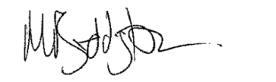
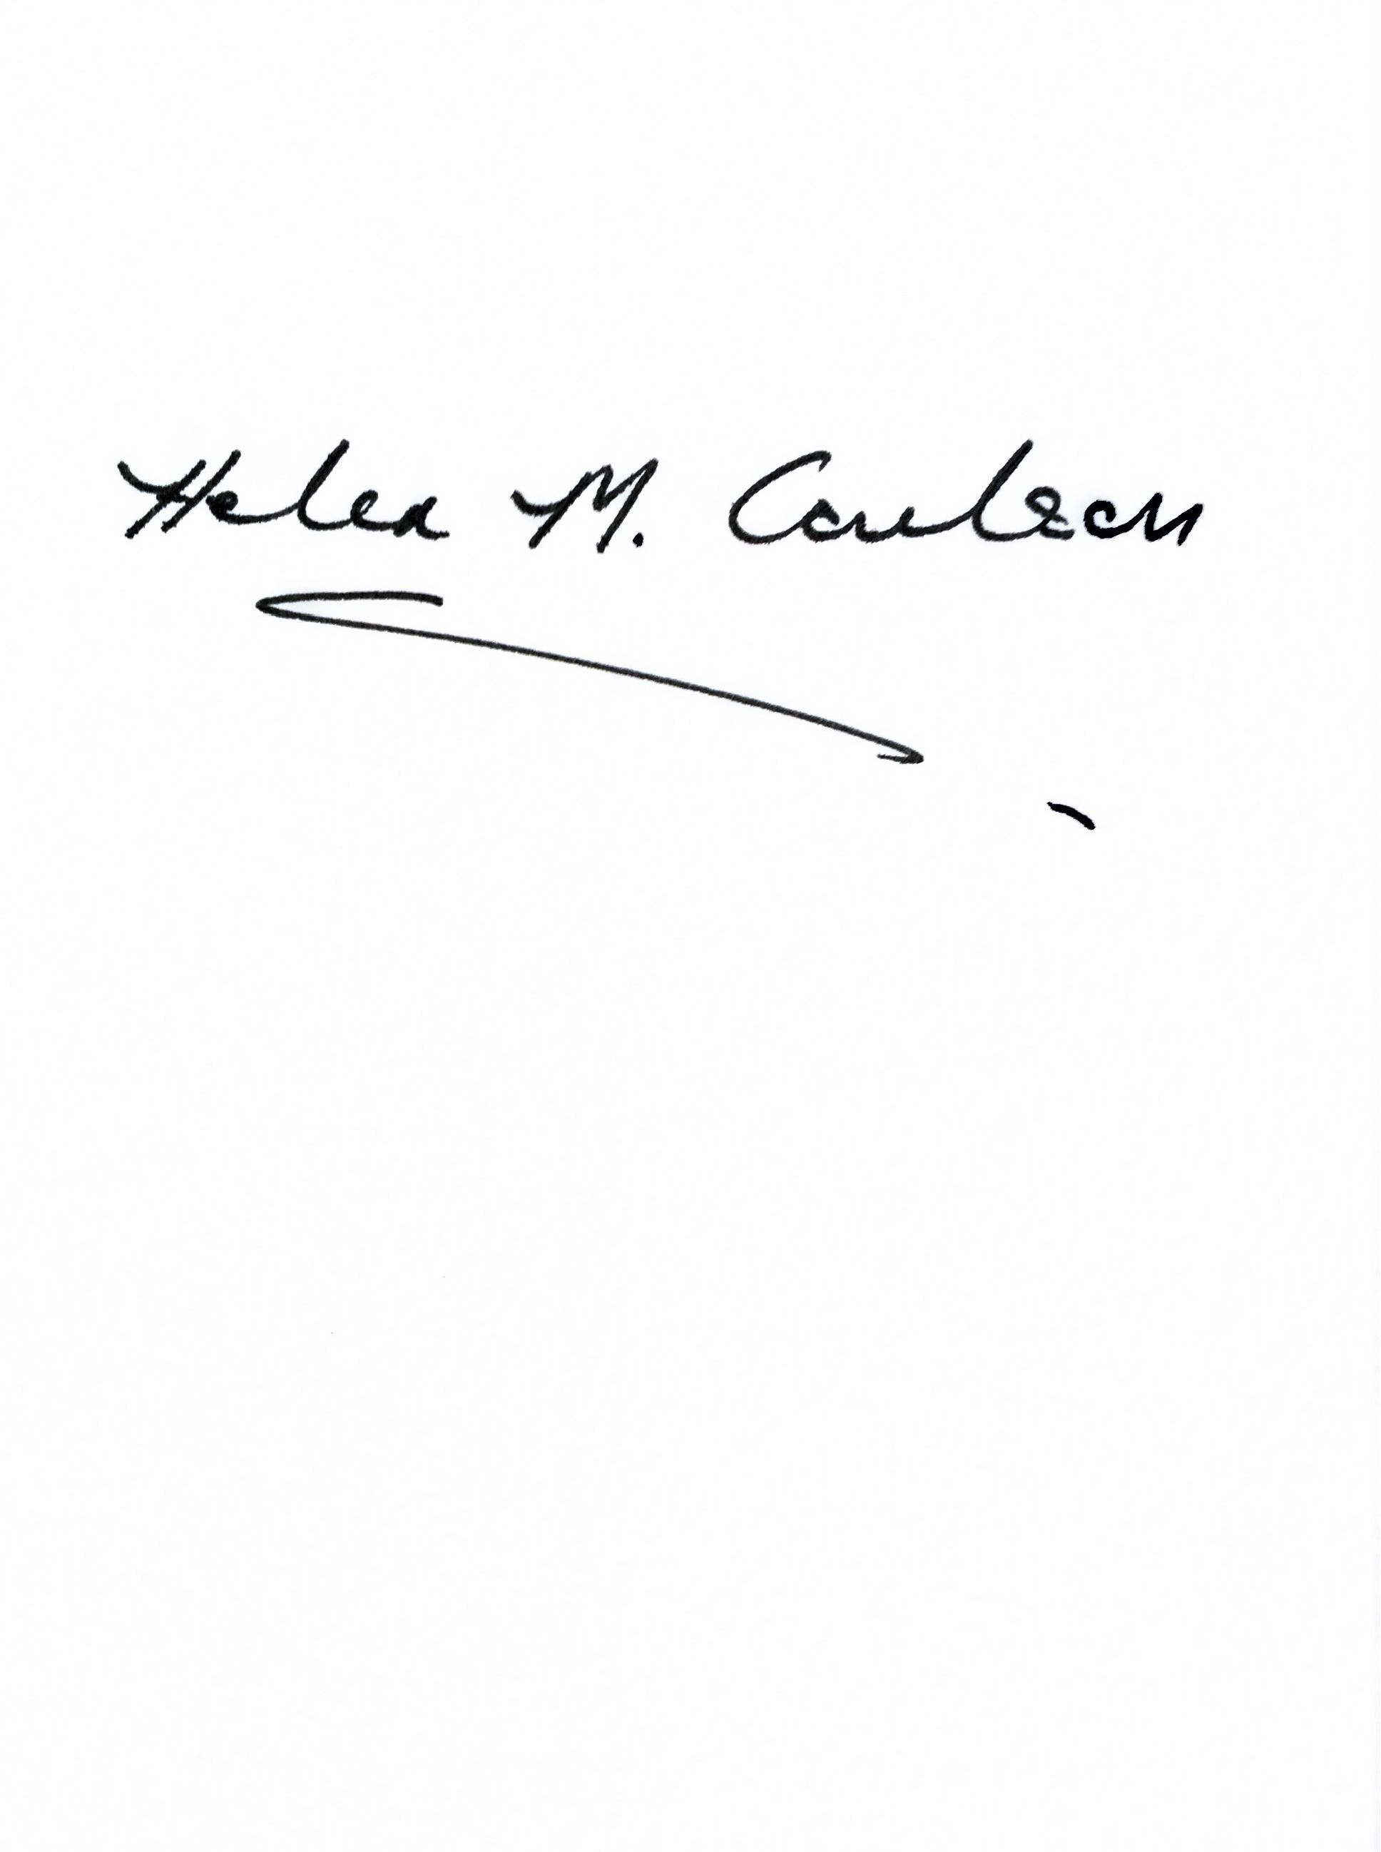

Signed: Helen Coulson Signed: Mike Boddington
Chair of Trustees Chief Executive Officer

Date: 18 July 2023 Date: 18 July 2023

